BubbleWrap: A Textile-Based Electromagnetic Haptic Display

【Abstract】：

We are investigating actuators that are able to provide different types of haptic sensations and that can be wrapped around a wide range of surfaces and objects. Our first prototype, BubbleWrap, consists of a matrix of electromagnetic actuators, enclosed in fabric, with individually controllable cells that expand and contract. It provides both active haptic feedback, using vibration, as well passive haptic feedback, using shape and firmness.

【BubbleWrap】：

It is a textile-based electromagnetic tactile display that can vibrate to generate active feedback, and can dynamically change its stiffness and shape to generate passive feedback. It consists of a matrix of electromagnetic actuators wrapped in fabric, with individually controllable retractable units. The fabric layer can be wrapped on a variety of surfaces or objects. BubbleWrap can be used in a variety of applications, such as flexible keyboards. Today's physical keyboards can obviously enter text efficiently, but take up space and are impractical for small mobile devices. The on-screen keyboard is useful but not very efficient, especially for touch typists. We can create a BubbleWrap keyboard that takes up very little space when not in use, but expands when needed, uses changes in shape and hardness to simulate keys and provides proprioceptive feedback when the user presses each key. We can also use vibration to notify users of input errors.

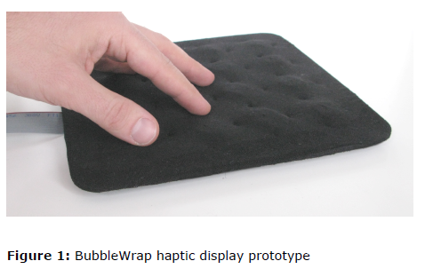 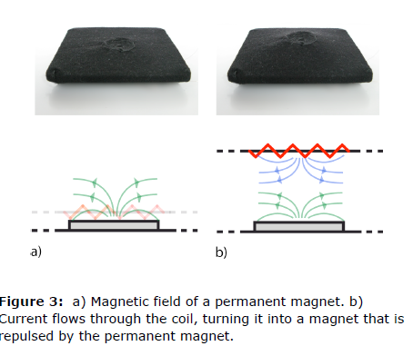

【Experiments】：

We measured the user's ability to distinguish between three different degrees of hardness produced by the BubbleWrap prototype. As a condition, we also use three different thicknesses of physical foam to measure the user's ability to distinguish between three different hardnesses.

【Important Reference】:

[6] E. Hoggan, S. A. Brewster and J. Johnston. Investigating the effectiveness of tactile feedback for mobile touchscreens. In Proc. of CHI '08, pages 1573-1582. ACM.

[11] I. Poupyrev, M. Okabe, and S. Maruyama. Haptic feedback for pen computing: directions and strategies. In CHI '04 Extended Abstracts, pages 1309-1312.